ТОВ „Стандарт-Рейтинг” (Україна)  04071, Україна, м. Київ,  вул. Введенська 4,  тел. +38 /044/ 383-59-64  факс +38 /044/ 383-27-50  http://www.standard-rating.biz/ |  | Standard-Rating (Ukraine) LLC  04071, Ukraine, Kyiv,  Vvedenska St. 4,  tel. +38 /044/ 383-59-64  fax +38 /044/ 383-27-50  http://www.standard-rating.biz/
11/10/2018
Ratings of PJSC “PRIVATBANK” are updated

October 11, 2018 at the meeting of the rating committee of RA “Standard-Rating” it was decided to update the ratings of PJSC “CB “PRIVATBANK” (14360570) according to the national scale:
- Long-term credit rating of PJSC “CB “PRIVATBANK” at the level uaAA according to the national scale with positive outlook. The Bank or the separate bond instrument with rating uaAA is characterized by a very high solvency compared to other Ukrainian borrowers or bond instruments.
- Short-term credit rating of PJSC “CB “PRIVATBANK” at the level uaK1 according to the Agency’s national scale.
- Rating of deposits of PJSC “CB “PRIVATBANK” is confirmed at the level ua.1 according to the scale of RA «Standard-Rating».

The decision to update the ratings of JSC “CB “PRIVATBANK” is taken according to the analysis results of the Bank’s activity for the 12 months of 2017 and for the first half of 2018, as well as data of the Bank’s statistical statements for January-August, 2018.

Balance sheet indicators
Dynamics of the Bank’s key balance sheet indicators during the first half of 2018 has demonstrated the following trends:

1. As of 01.07.2018 the Bank’s shareholders’ equity has amounted to UAH 28,038 bn. For the first half of 2018 the Bank’s shareholders’ equity has grown by 9,49%. The increase in shareholders’ equity deserves a positive assessment and became possible, mostly, due to the Bank’s profitable activity. The Bank’s authorized capital for the first half of 2018 has remained unchanged and has amounted to UAH 206,06 bn.

Table 1
Key balance sheet indicators of JSC «CB «PRIVATBANK», mln. UAH, %, p.p.
Indicators | 01.07.2018 |  | 01.01.2018 |  | Growth rate, %
 | mln. UAH | % | mln. UAH | %
Debt to NBU | 9796 | 3,68% | 12394 | 4,78% | -20,96%
Debt to banks and financial organizations | 65 | 0,02% | 234 | 0,09% | -72,22%
Funds of clients | 217718 | 81,87% | 208566 | 80,51% | 4,39%
Total liabilities: | 237898 | 89,46% | 233454 | 90,12% | 1,90%
Authorized capital of the bank | 206060 | 77,48% | 206060 | 79,54% | 0,00%
Total shareholders’ equity: | 28038 | 10,54% | 25608 | 9,88% | 9,49%
Cash and its equivalents and mandatory reserves | 22586 | 8,49% | 19697 | 7,60% | 14,67%
Financial assets at fair value through profit or loss | 83412 | 31,37% | 34435 | 13,29% | 142,23%
Funds in other banks | 6508 | 2,45% | 7937 | 3,06% | -18,00%
Customer credits and debt | 44011 | 16,55% | 38118 | 14,71% | 15,46%
Securities at fair value through other total income | 60130 | 22,61% | 90224 | 34,83% | -33,35%
Securities at amortized cost | 22300 | 8,39% | 39175 | 15,12% | -43,08%
Other financial assets | 10130 | 3,81% | 11483 | 4,43% | -11,78%
Other assets | 9740 | 3,66% | 13526 | 5,22% | -27,99%
Total assets: | 265936 | 100,00% | 259061 | 100,00% | 2,65%
Source: Bank’s statements according to NBU data

2. Customer credits and debt of the Bank, excluding reserves for the first half of 2018, have grown by 15,46% up to UAH 44,011 bn.
On 01.07.2018, according to NBU data, the Bank’s BISL portfolio has amounted to UAH 148,049 bn that is 55,67% of the Bank’s net assets. In Ukraine the BISL, as state securities, are identified as assets with the lowest risk rate. Thus, even with the availability of the loan portfolio of bad quality, in general the Bank’s asset quality can be considered as quite suitable to ensure its continuous operation and customer demand for liquidity.

3. The Agency reminds that debt of PJSC “CB “PRIVATBANK” to NBU according to the results of 2017 has reduced by 31,32%: from UAH 18,047 bn. down to UAH 12,394 bn. In the first quarter of 2018 the Bank’s debt to NBU has increased by 5,87%. As of 01.07.2018 compared to the beginning of 2018 the Bank’s debt to NBU has reduced by 20,96% down to UAH 9,796 bn. In the Agency’s opinion, fluctuations of the Bank’s debt to NBU are of natural character. The Bank has had sufficient liquidity to pay debt, and the need of its support was of technical character.

Normative indicators
Regulatory capital normative of JSC “CB “PRIVATBANK” as of 03.09.2018 has amounted to UAH 20,634 bn with the limit value, set by NBU, in the amount of UAH 200 mln. Current amount of the Bank’s N1 ratio indicates the fact that JSC “CB “PRIVATBANK” fully fulfils new NBU requirements to the N1 ratio and has a very great reserve to this normative. The probability of the Bank’s non-compliance of this normative, in the Agency’s opinion, is zero.

As of 03.09.2018 the Bank’s regulatory capital adequacy normative has amounted to 18,69%. Throughout almost a year the Bank hasn’t violated the N2 ratio. Moreover, for July of 2017 the Bank has achieved a gradual increase in the N2 ratio and in fact on 03.09.2018 has formed a reserve of 8,69 p.p. on N2 ratio.

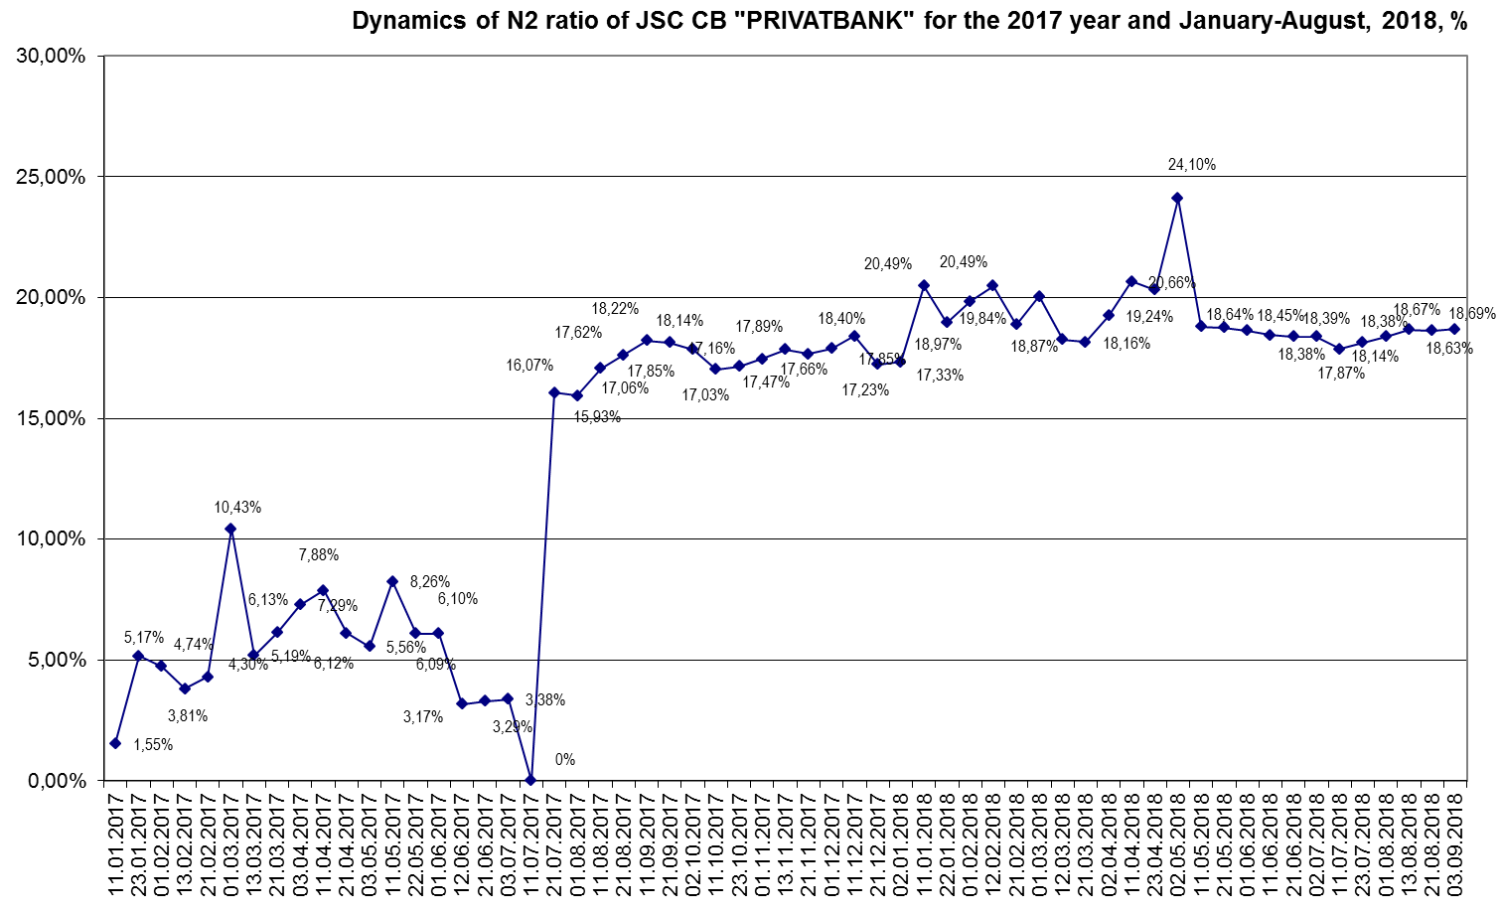

In the Agency’s opinion, the Bank was very well provided with regulatory capital. Besides, a positive impact on the loan risk of the Bank was provided by a high level of external support from its shareholder – the State Ukraine represented by the Ministry of Finance of Ukraine, which has repeatedly demonstrated the possibility of such support in practice.

Liquidity ratios of PJSC “CB “PRIVATBANK” for the period from 01.01.2018 to 01.07.2018 have demonstrated the following dynamics:
- Instant liquidity ratio (N4) has increased from 32,47% up to 38,37%;
- Current liquidity ratio (N5) has decreased from 155,54% down to 147,44%;
- Short-term liquidity ratio (N6) has grown from 99,76% up to 100,19%.

Table 2
Key norms of JSC «CB «PRIVATBANK», mln. UAH, %, p.p.
Indicator | Normative indicator | 01.07.2018 |  | 01.01.2018
 |  | on the system | bank | on the system | bank
Norm of regulatory capital adequacy (N2) | >10% | 16,44% | 18,39% | 16,10% | 17,33%
Norm of instant liquidity (N4) | >20% | 56,61% | 38,37% | 55,55% | 32,47%
Norm of current liquidity (N5) | >40% | 104,21% | 147,44% | 108,08% | 155,54%
Norm of short-term liquidity (N6) | >60% | 94,82% | 100,19% | 98,37% | 99,76%
Norm of the maximum amount of credit risk per one counterparty (N7) | <25% | 20,02% | 5,81% | 20,29% | 5,70%
Norm of large loan risks (N8) | <800% | 155,56% | 0,00% | 208,31% | 0,00%
Note: if there is no calculation of the normative at the first of each months, the Agency provides data of the closest working day in the reported month
Source: NBU data and data of the Bank’s statistical statements

Therefore, the Bank has maintained a very good reserve of liquidity ratios. The Bank’s N5 and N6 ratios on 01.07.2018 have exceeded not only the limit values, set by NBU, but also the averages of these normative indicators on the Ukrainian banking system. Besides, as of 03.09.2018 the Bank has had the following liquidity ratios: N4 – 38,28%, N5 – 146,11%, N6 – 98,33%. Thus, the Bank has been very well provided with liquidity throughout the 2017 year and the first eight months of 2018.

Revenues and expenses
The Agency reminds that for the 12 months of 2017 JSC “CB “PRIVATBANK” has received a loss of UAH 22,966 bn, the Bank’s unprofitable activity has occurred mostly due to significant deductions in asset reserves formed at the Bank’s balance prior to nationalization. In the first quarter of 2018 the Bank’s profit has increased up to UAH 3,654 bn, for the first half of 2018 the profit has grown up to UAH 6,926 bn. As well, one should note a number of positive trends, which indicate a renewal of the Bank’s generation of key income items in the first half of 2018 compared to the same period of 2017:
- Increase in net interest income by 264,29%;
- Increase in net commission income by 44,35%.
Table 3
Data on key articles of income and expenses of JSC «CB «PRIVATBANK», mln. UAH, %
Indicator | І half of 2018 | І half of 2017 | Change | Growth rate, %
Interest income | 13977 | 11789 | 2188 | 18,56%
Interest expenses | 6939 | 9857 | -2918 | -29,60%
Net interest income | 7038 | 1932 | 5106 | 264,29%
Commission income | 9318 | 6423 | 2895 | 45,07%
Commission expenses | 1991 | 1347 | 644 | 47,81%
Administrative and other operating expenses | 5791 | 4631 | 1160 | 25,05%
Profit / (loss) | 6926 | -2908 | 9834 | -
Source: Bank’s statements according to NBU data

The Agency appreciates the Bank’s return to profitable activity and notes the weakening of the Bank's dependence on the support of its shareholder – the State of Ukraine represented by the Ministry of Finance.

Other factors
JSC “CB “PRIVATBANK” due to the scales of its activity continues to remain a strategic interest of the State Ukraine. The state’s participation in the equity of PJSC “CB “PRIVATBANK” provides the basis for a stable functioning of the domestic banking system.

The analysis of court disputes that continues around the procedure for nationalization of PJSC CB "PRIVATBANK" has shown that in most cases, the main claims of plaintiffs concern the procedure for nationalization and recognition of the circle of related persons. As before, the Agency assumes that a part of court disputes may create an additional burden on the Bank's liabilities, but the Bank has sufficient liquid funds and a guaranteed, verified in practice support from the shareholder so that the said risks do not affect its long-term credit rating.

In addition, the Agency reminds that a long-term credit rating of PJSC CB “PRIVATBANK” according to the national scale was assigned on December 29, 2016, already after nationalization. The agency believes that the process of nationalization was performed with a minimum of losses for its clients. The Agency assumes the availability of court disputes on the part of those bank lenders that fall under the normative definition of "related persons", but the fact of such disputes does not directly affect the credit risk of the Bank.

Therefore, JSC CB «PRIVATBANK» was very well provided with liquidity and regulatory capital, had a high level of external support from the shareholder represented by the State Ukraine, and from July, 2017 provided the increase in the Bank’s regulatory capital adequacy. In the first half of 2018 the Bank has demonstrated not only profitable activity, but also has provided an increase in key income items. Continuance of the revealed positive trends in the third and fourth quarters of 2018 can result in the improvement of the Bank’s credit rating according to the national scale.

Rating agency «Standard-Rating» (Ukraine)

